Skill Test 2 – Container Orchestration
Objective
Deploy a microservices application on Kubernetes using Minikube, ensuring proper service communication and configuration.
Application Components
You are provided with four containerized Node.js microservices:
- User Service (Port 3000)
- Product Service (Port 3001)
- Order Service (Port 3002)
- Gateway Service (Port 3003)
Task Requirements
1. Basic Kubernetes Deployment
A. Create Kubernetes Deployment manifests for all services
- User Service deployment
- Product Service deployment
- Order Service deployment
- Gateway Service deployment (includes additional proxy handling setup if required)
Each deployment must include:
- Correct container image reference
- Resource limits and requests
- Environment variables
- Liveness and readiness probes
- Proper labels and selectors
B. Create corresponding Service resources
- Configure correct ports
- Choose proper service types
- Enable cluster-level service discovery using ClusterIP
2. Minikube Setup and Validation
- Initialize and configure Minikube
- Deploy all components successfully
- Validate inter-service communication using curl or logs
3. Documentation and Testing
Provide a well-structured README.md with:
- Minikube setup steps
- Deployment process using kubectl apply -f
- Service testing instructions using kubectl port-forward or direct service names
- Troubleshooting tips
Include screenshots of:
- Running pods (kubectl get pods)
- Logs showing service communication
- Any port-forwarded test results
Results
- Building the docker images of the services
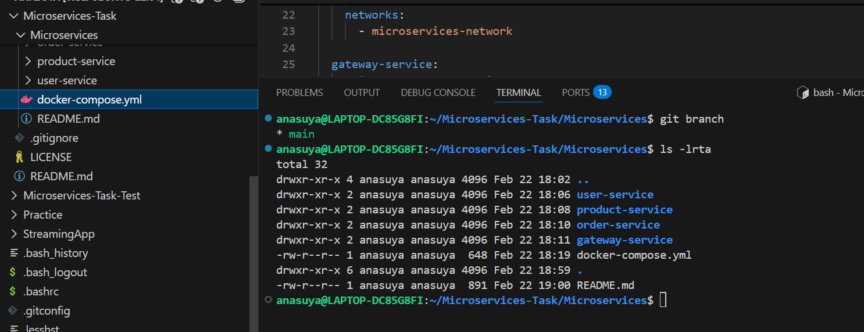
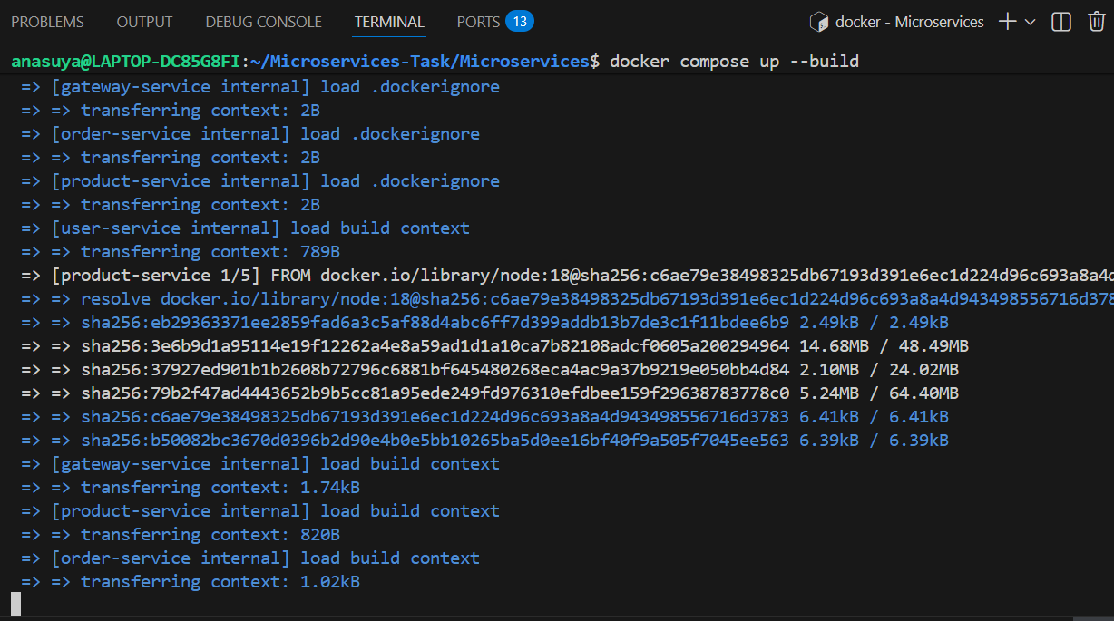
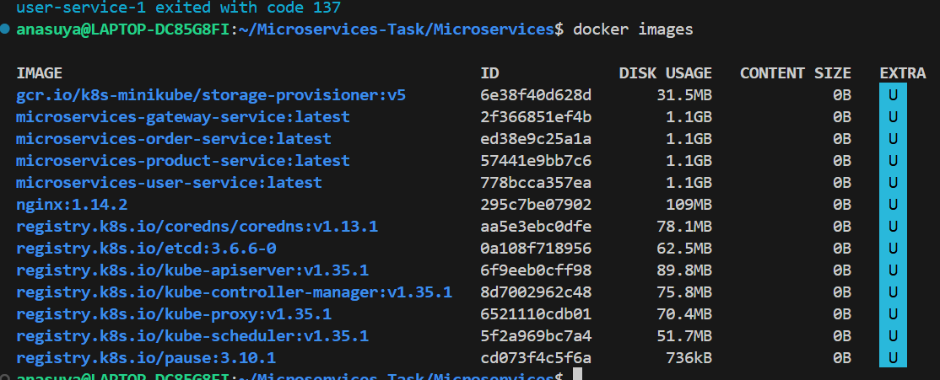

- Use Minikube Docker Environment
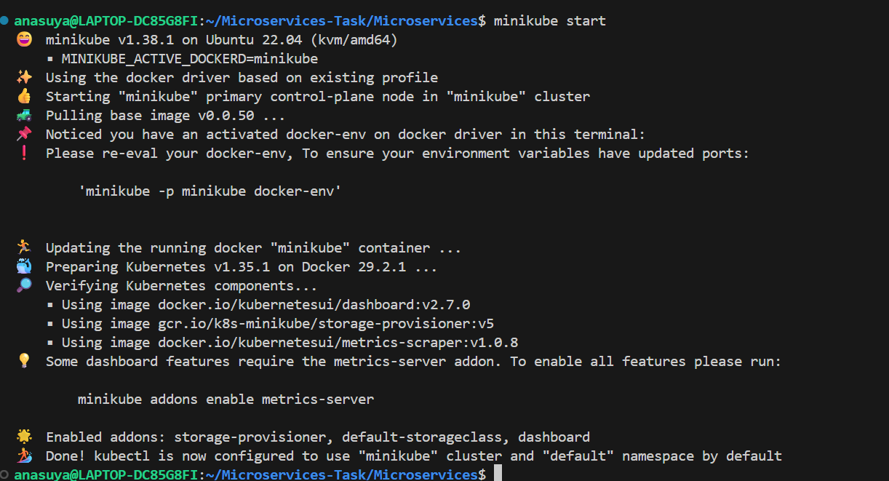

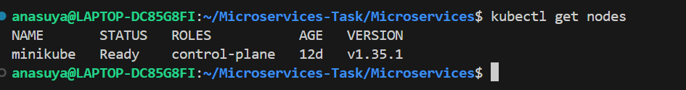

- Rebuild Images INSIDE Minikube
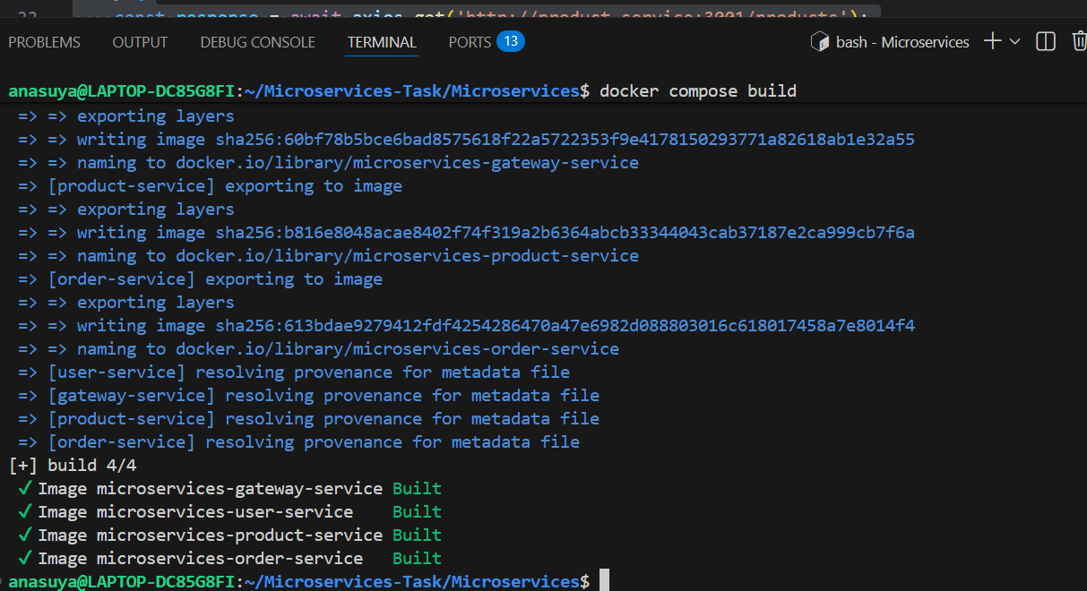

- Kubernetes Deployment:

Creating YAML deployment files :

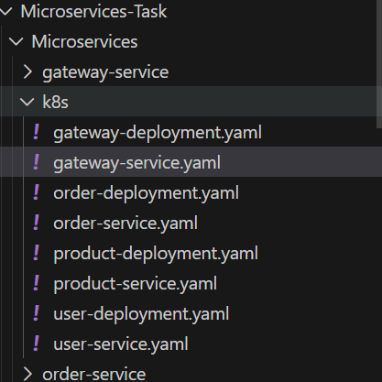
  - USER SERVICE
  - Product service
  - Services service
  - Gateway service
Deploy all the services

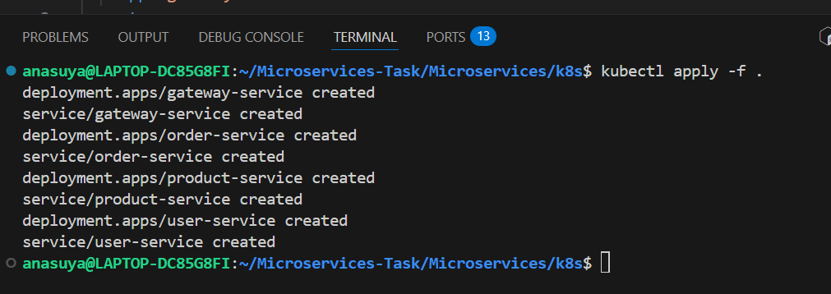

Verifying all the pods – All are running fine
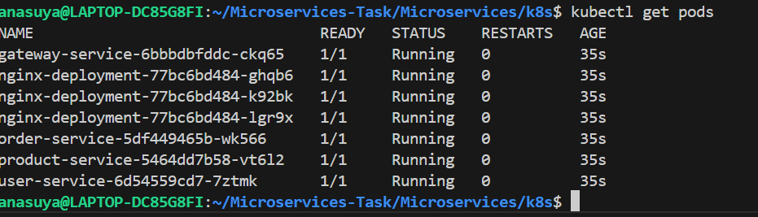
Verifying services
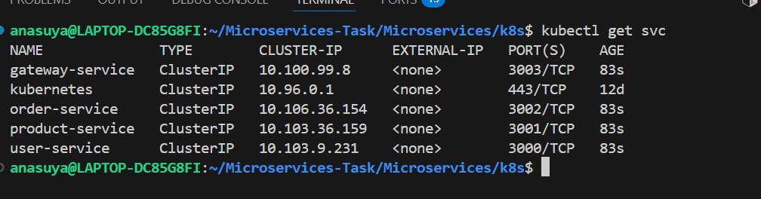

- Testing:
  - Port Forward
kubectl port-forward svc/gateway-service 3003:3003

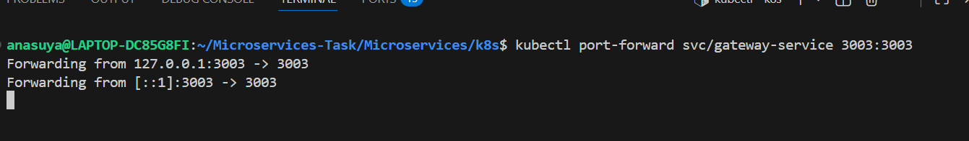

  - Gateway-service logs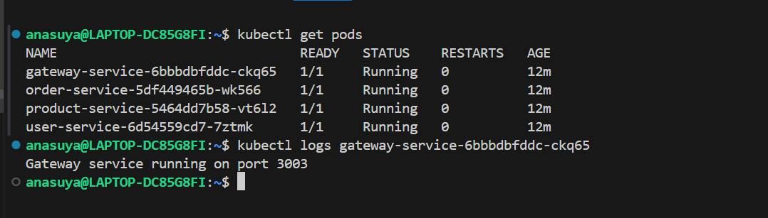

  - User – Service End point – localhost:3003/api/users
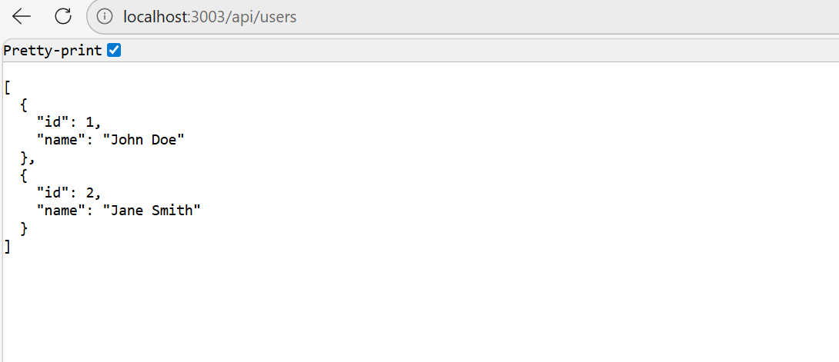
  - Product -service - localhost:3003/api/products
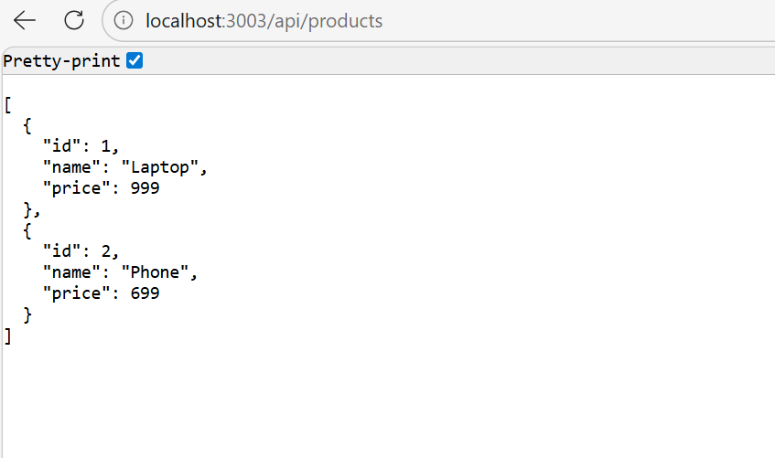
  - order-service - localhost:3003/api/orders
